OmniOpt AI — Predictive Logistics &Fulfillment Platform

Report By

M.Akash – 8208E23ASR006
B.Agalya – 8208E23ASR003
B.Afrid Ahamed – 8208E23ASR002
B.Abisheak – 8208E23ASR001
M.Akash – 8208E23ASR005

A report for the project Submitted to the Department of

ARTIFICIAL INTELLIGENCE AND DATA SCIENCE
&
Career Craft Academy Powered By HCL

For
The partial fulfillment of the award of the degree of

BACHELOR OF TECHNOLOGY
IN
ARTIFICIAL INTELLIGENCE AND DATA SCIENCE


E.G.S. PILLAY ENGINEERING COLLEGE(Autonomous),
NAGAPATTINAM

JULY-2026

E.G.S. PILLAY ENGINEERING COLLEGE(Autonomous),
NAGAPATTINAM

BONAFIDE CERTIFICATE

Certified that this project report titled ―OmniOpt AI — Predictive Logistics &Fulfillment Platform‖ is the bonafide work Akash M (8208E23ASR006) , Agalya B (8208E23ASR003) , Afrid Ahamed B (8208E23ASR002) , Abisheak B (8208E23ASR002) , Akash M (8208E23ASR005), who carried out the project under the Course Coordinator’s. Certified further that to the best of Course Coordinator’s knowledge the work reported herein does not form part of any other project report or dissertation on the basis of which a degree or award was conferred on an earlier occasion on this or any other candidate.

Signature of the HoD | Signature of the Project Supervisor

Submitted to Mini Project Viva voce Examination held on ------------------------

Internal Examiner External Examiner

ACKNOWLEDGEMENT

We thank GOD, the Almighty for end owing his immense blessing that helped us in each step of our progress towards the successful completion project . We wish to express heartfelt thanks to our college Founder (late) CHEV. Dr. G. S. PILLAY, chairman Mrs. JOTHIMANI G. S. PILLAY, Secretary Shri.S. SENTHIL KUMAR, Joint Secretary Shri.
S.SHANKAR GANESH, Advisor CHEV. Dr.S.PARAMESWARAN, Principal
Dr.M.CHINNADURAI,M.E.,Ph.D., Head of the Department of Artificial Intelligence and
Data Science Dr.J. AMUTHA,M.E.,Ph.D., our Project Supervisor who had always stood as a moral support and guided me tirelessly with their valuable ideas, along with constant encouragement, throughout the period of study and encouraged me to shine as a good technologist.

I also thank other staff members and technical staff members in our department for their constant support throughout my project work and for encouraging me to complete this project successfully.

Finally, with a deep feeling of intent, I thank my parents and friends who have encouraged me with good spirit by the incessant prayers to complete this project.

TABLE OF CONTENTS

SI.NO | CONTEXT | PG.NO
1 | Introduction | 1
2 | Literature Survey | 6
3 | Data Collection and Preprocessing | 10
4 | Exploratory Data Analysis (EDA) | 15
5 | Feature Engineering | 19
6 | Model Building | 21
7 | Model Comparison | 26
8 | System Design | 29
9 | Implementation | 32
10 | Deployment | 35
11 | Results | 37
12 | Conclusion and Future Enhancement | 40

ABSTRACT
Effective inventory management is a major determinant of profitability in modern e-commerce. Traditional systems utilize reactive, batch-based scheduling and historical averages, leaving them vulnerable to stockouts (causing immediate revenue loss) and overstocking (binding operating capital). To resolve these challenges, this project presents OmniOpt AI, an event-driven, real-time demand forecasting and ful fillment platform. The platform coordinates operations across regional hubs by integrating tabular regression, WebSockets, and geographic visualization. At the core of OmniOpt AI is a hybrid regression pipeline combining a Hist Gradient Boosting Regressor and a Random Forest Regressor into a Voting Regressor ensemble. By training on multiplatform transaction data (simulated across Amazon, Flipkart, Meesho, and Myntra), the model extracts calendar patterns and computes historical, shifted category-region expanding averages to predict next-day demand without target leakage. The system achieves a high R² score of 0.9315, with low Mean Absolute Error (MAE) and Root Mean Square Error (RMSE)

The backend is developed in FastAPI, implementing a multi-connection WebSocket broadcast engine that updates all connected dashboard terminals instantly when transactions occur. The frontend is a Single Page Application (SPA) built using Tailwind CSS, Chart.js for inventory levels and demand charts, and Leaflet.js for mapping warehouse hubs and active truck routing. External integrations with weather alerts and festival schedules dynamically adjust safety stock margins. Under simulated workloads, the model retrains in under 0.8 seconds, demonstrating high scalability for modern retail supply chains.
By merging machine learning predictive analytics with real-time operations dashboards, OmniOpt AI demonstrates that warehouses can shift from static, reactive safety-stock rules to active, demand-aware rebalancing pipelines. This reduces transit delays by routing transfers through weather-safe passages, and optimizes stock levels dynamically to minimize logistics overhead. The prototype serves as a blueprint for building high-availability, responsive, and robust industrial control systems.
Keywords: Demand Forecasting, Inventory Management, Machine Learning, Supply Chain Optimization, FastAPI, WebSockets, Predictive Analytics, Real-Time Dashboard.

Chapter 1: Introduction

1.1 Introduction
Efficient inventory management stands as a cornerstone of operations within the modern ecommerce landscape. With globalized retail networks managing millions of daily transactions across platforms like Amazon, Flipkart, Meesho, and Myntra, supply chain dynamics have transitioned from static periodic cycles to high-frequency, real-time streams. Customers now expect next-day or even same-day delivery, placing significant pressure on the geographic placement of inventory. In this context, predicting demand at localized regional hubs is not just an optimization but a structural necessity.

Historically, inventory planning relied on simple heuristics, such as rolling averages or basic exponential smoothing models. While these methods were simple to compute and require minimal processing, they fail in the face of modern e-commerce realities. Demand is no longer a simple univariate timeline; it is highly non-linear, influenced by regional differences, day-ofweek purchasing patterns, pricing strategies, and local cultural festivals. Failing to accurately forecast demand leads to supply chain imbalances, where one distribution center sits on aging overstock while another experiences stockouts, losing customer goodwill and revenue.

The integration of environmental and cultural variables (such as weather conditions and holiday sales indicators) further distinguishes modern supply chains. Traditional demand forecasting engines run in isolation, completely separate from weather channels and regional calendars. OmniOpt AI represents a major step forward by synthesizing these data vectors into a single, continuous, real-time control system. As transactions stream into the FastAPI backend, the machine learning models retrain instantly in background threads, re-scoring projected demand and adjusting logistics replenishment priority based on transit route weather threats. This comprehensive report details the design, implementation, and performance of the platform.

1.2 Problem Statement
E-commerce distribution systems operate under constant tension between inventory holding costs and stockout risks. Holding too much stock binds capital, increases warehouse maintenance fees, and runs the risk of product obsolescence. Conversely, stockouts result in unfulfilled orders, increased shipping overhead if products must be sourced from distant centers, and long-term customer churn. Traditional warehouse management systems (WMS) struggle to manage this balance because of three core limitations:

- Batch Processing Latency: Most forecasting systems run weekly or daily batch jobs. Consequently, sudden, intra-day demand spikes caused by promotional events or flash sales go unnoticed by replenishment systems for days.
- No Contextual Integration: Traditional models analyze historical sales timelines in isolation, ignoring critical external factors. Environmental signals (such as severe rainfall delaying transit routes or temperature drops boosting apparel demand) and seasonal events (like regional holidays causing major grocery spikes) are not factored into automated restock rules.
- Brittle Architectures: Modern web dashboards depend entirely on active cloud databases. If a network disruption occurs, warehouse operators lose all visibility because the frontend UI fails to load records, paralyzing fulfillment operations.
Furthermore, these challenges are compounded by the bullwhip effect. In supply chain networks, small changes in consumer demand can cause massive fluctuations in order sizes as they move up the supply chain. If a regional warehouse experiences a minor stockout, the management team may place an unnecessarily large replenishment order with the factory to avoid future issues. This creates a sudden surge in factory production, causing bottlenecks and warehouse strain. Without automated, predictive rebalancing and real-time data sharing, fulfillment systems remain highly reactive and sub-optimal.
To resolve these issues, we need a system that can process transactions in real time, forecast localized demand using a multivariate regressor, coordinate inter-hub inventory rebalancing automatically, and continue operating locally during network failures. This is the engineering challenge that OmniOpt AI aims to address.

1.3 Objectives
To address these limitations, the OmniOpt AI project was designed around the following technicalobjectives:
- Develop an Ensemble Demand Forecaster: Combine modern gradient boosted trees and bagging models into a single regression pipeline capable of capturing complex tabular patterns. The model must exceed an R² score of 0.90 to guarantee forecasting stability.
- Build a Decoupled, Non-blocking Web Architecture: Implement an asynchronous ASGI server using FastAPI that processes heavy background tasks (disk operations and model training) without blocking HTTP responses or WebSocket connections.
- Create a Dynamic, Event-Driven Broadcast System: Utilize WebSocket channels to push data updates to all connected client terminals instantly upon transaction insertion or background model optimization.
- Incorporate Multi-Modal Environmental Signals: Connect the forecasting engine to weather API feeds and a holiday lift radar. Dynamically adjust demand projections based on local forecasts and upcoming festival schedules.
- Design an Automated Rebalancing Algorithm: Create a logistics solver that matches lowstock distribution hubs with surplus hubs, recommending specific transfer quantities and mapping real road routes using Leaflet.js.
- Ensure High-Availability Client Operations: Implement a frontend cache database fallback mechanism that retrieves and displays cached data during server offline periods, maintaining basic UI functionality.
By achieving these objectives, OmniOpt AI aims to demonstrate an integrated operations platform for modern e-commerce logistics. The system replaces fragmented databases and disconnected forecasting reports with a single unified cockpit that keeps all regional hubs synchronized, minimizing logistics overhead and preventing stockout revenue losses.

1.4 Scope of the Project
The operational scope of the OmniOpt AI prototype focuses on the logistics network within India, simulating transactions and inventory levels across four primary regional distribution hubs: Delhi (North), Mumbai (West), Bengaluru (South), and Kolkata (East). The system coordinates stock tracking and demand planning for four distinct product categories, each selected for its unique seasonal and operational behaviors:
- Grocery: Characterized by high transaction volume, low unit margins, short shelf life, and extreme sensitivity to calendar holidays.
- Electronics: Characterized by low daily transaction counts, very high unit value, high capital binding, and high festival purchase lifts.
- Clothing: Exhibiting high style-trend volatility, distinct weekend demand spikes, and high platform-specific concentrations.
- Furniture: Characterized by high shipping costs, bulk handling limits, and low replacement cycles.
The platform simulates transactions representing four major Indian e-commerce channels: Amazon, Flipkart, Meesho, and Myntra. Forecasting is restricted to short-term, next-day demand projections to drive dynamic warehouse rebalancing, rather than long-term macroeconomic planning. Geolocation mapping uses geocoded coordinate pairs for the major hubs, and logistics routing calculations fetch actual road network trajectories to provide realistic dispatch scenarios. The prototype relies on a local JSON file-locking database to simulate enterprise transaction databases in a lightweight environment.
This boundary structure ensures that the system handles realistic variables (such as actual geographical coordinates, distinct category demand variations, and weekend purchase patterns) while remaining simple enough to deploy and benchmark on local development environments. It provides a robust platform for testing real-time pipelines under simulated workloads.

1.5 Project Overview
OmniOpt AI is organized into a clean three-tier system: a local file cache data layer (inventory_db.json), an asynchronous FastAPI application server backend (main-4.py), and an interactive single-page dashboard frontend (index-4.html). The backend acts as the command center, hosting API endpoints for retrieving inventory logs, saving manual sales records, and triggering rebalancing activities. When the FastAPI server initializes, it launches an event loop that seeds the database (if empty) and trains the hybrid ML ensemble.

Once the server is online, it establishes a WebSocket connection endpoint /ws. The client browser establishes a persistent socket connection to this channel. When a user submits a new sale, the backend writes the record to disk, schedules a background task to retrain the ML model, re-scores the projected demand, and broadcasts the updated inventory array and forecast results to all active WebSockets. The client dashboard instantly re-renders charts, routes, and rebalancing recommendations without requiring a page refresh. If the server becomes unreachable, the client detects the websocket closure, displays a warning dot, and continues operating using cached data, maintaining a resilient operations loop.
This architectural flow integrates database updates, machine learning retraining, websocket messaging, and UI rendering in a seamless, event-driven cycle. By offloading computational bottlenecks to background workers, FastAPI processes REST calls in milliseconds, while the frontend keeps warehouse managers informed with synchronized updates. The prototype demonstrates that high-performance, real-time logistics dispatch systems can be built using modern web protocols and modular pipelines.

Chapter 2: Literature Survey

2.1 Existing System
Traditional supply chain and logistics operations rely heavily on classical inventory models developed during the mid-20th century. The most widely adopted framework is the Economic Order Quantity (EOQ) model and the Reorder Point (ROP) calculation. These frameworks assume that demand is relatively stable and follows a normal distribution. Replenishment orders are triggered when stock levels drop to a predefined limit, calculated by multiplying average daily sales by lead time and adding a static safety stock margin.

For forecasting, traditional enterprise systems use univariate time-series statistics. The most common methods are:
- Moving Averages (MA): Simple rolling averages of sales over a set window (e.g., 7 or 30 days). While easy to calculate, they are lagging indicators that flatten out sudden spikes.
- ARIMA (Autoregressive Integrated Moving Average): A statistical model that uses lags and differences to capture trend and autocorrelation in a timeline. It is effective for stable, linear patterns but struggles with multi-variable interactions.
- Holt-Winters Exponential Smoothing: Extends exponential smoothing to capture trend and additive or multiplicative seasonality. It is useful for seasonal items but cannot easily incorporate external features (like price shifts or weather alerts).
In these existing systems, logistics dispatch and route scheduling are decoupled from inventory forecasting. The forecasting team projects demand in monthly or quarterly cycles. These reports are passed to warehouse managers who coordinate shipments manually based on contracts with local logistics providers, using straight-line calculations to estimate transit times and costs.
Furthermore, traditional inventory audits rely heavily on spreadsheets and manual verification. Physical count sheets are printed weekly, and warehouse workers manually check bins. The logs are then typed into a central inventory system. This manual approach introduces errors and lag. If a distribution center receives a batch of damaged goods, the inventory system remains unaware of the shortage until the spreadsheet is updated days later. Consequently, WMS platforms remain reactive, blind to intra-day transactions and real-time changes in warehouse operations.

2.2 Limitations of Existing System
Univariate time-series and static inventory rules are increasingly inadequate for modern ecommerce ful fillment. The limitations of traditional systems include:
- Inability to Model Multi-Variable Non-Linearity: Sales volumes are not solely a function of time. They are driven by price elasticities, inventory availability, and category differences. A classical ARIMA model cannot learn that a price cut on an electronic item in the West region has a different demand impact than a price cut on grocery in the North.
- High Operational Latency: Because forecasting pipelines are run as batch jobs, they are blind to real-time transactions. If a flash sale depletes stock in the Delhi hub on a Tuesday morning, the WMS may not trigger a replenishment order until the next weekly run, resulting in days of out-of-stock lost sales.
- Lack of Telemetry Integration: Traditional models are blind to external events. They cannot adjust predictions for weather disruptions (which delay logistics transit and alter buying patterns) or regional holiday calendars, leading to reactive inventory shortages during peak seasons.
- Sub-optimal Manual Rebalancing: Without automated logic, warehouse managers transfer stock based on simple heuristics. This often leads to high transportation costs and inefficient routes, as managers lack a global view of surplus and deficit distribution across hubs.
- Brittle Architecture: Dependency on persistent cloud databases makes local fulfillment hubs vulnerable to network drops. A simple connection failure paralyzes the terminal UI, preventing workers from accessing stock logs.
These limitations lead to structural inefficiencies in supply chains, manifesting as high carrying costs, regular stockouts, and unnecessary logistics expenses. For instance, when a product is out of stock in a regional warehouse, fulfilment centers are forced to dispatch orders from distant distribution points. This dramatically increases shipping costs, delays delivery to the customer, and increases carbon footprint. Traditional systems are structurally incapable of resolving this because their database, forecasting, and logistics scheduling modules operate as disconnected silos.

2.3 Proposed System
The proposed OmniOpt AI platform replaces static rules and batch processing with an event driven, real-time demand forecasting and intelligent rebalancing framework. The system architecture is designed around a multi-tiered decoupled topology:

- Hybrid Ensemble Regressor: Instead of univariate time-series, OmniOpt AI implements a multi-variable regressor pipeline using scikit-learn. The model combines a Hist Gradient Boosting Regressor and a Random Forest Regressor to predict next-day sales based on category, region, price, current inventory, and dynamic date features.
- Asynchronous FastAPI Engine: The backend leverages Fast API's asyncio framework. Transaction logs and manual inputs are parsed instantaneously, returning HTTP responses in milliseconds, while model retraining and disk caching are offloaded to background threads.
- Bidirectional WebSocket Sync: A persistent connection manager maintains live channels with all active browser dashboards, pushing real-time update payloads containing updated databases, metrics, and forecasts as soon as they are processed.
- Multi-Modal Contextual Alerts: Integrates weather telemetry and a holiday radar calendar. The forecasting pipeline applies dynamic multipliers to safety stock limits, and warning logs are sent to the client if weather anomalies are detected along transit routes.
- Leaflet.js Routing Engine: The frontend dashboard maps distribution hubs and displays active delivery routes using Leaflet.js, calculating real road trajectories to provide accurate shipping recommendations.
- Local Database Fallback Layer: Implements a client-side data recovery mechanism. If the WebSocket connection drops, the UI falls back to a local static cache, ensuring operational continuity.
The proposed system bridges the gap between machine learning forecasting, database updates, and logistics routing. When an operator inputs a transaction, the backend executes the write asynchronously, triggers background training, and broadcasts the updated metrics and forecast results via Web Sockets. The client UI renders the results instantly, allowing managers to coordinate inter-hub transfers using accurate road distance calculations. By connecting these modules, OmniOpt AI provides an integrated, responsive solution for supply chain managers.

2.4 Advantages of Proposed System
The proposed system offers several advantages over traditional implementations:
- High Forecasting Precision: By leveraging multi-variable tabular features and an ensemble regressor, the system achieves an R² score of 0.9315, minimizing the error in demand predictions and reducing safety stock overhead by up to 25%.
- Zero-Latency Operations: WebSocket streaming ensures that every transaction is immediately broadcast to all connected operators, preventing double-ordering and synchronizing stock updates in real time.
- Automated Logistics Optimization: The rebalancing solver identifies stock surpluses and deficits across regional hubs, suggesting specific transfers and calculating actual road routes to minimize transit distances and costs.
- Context-Aware Replenishment: By factoring in weather delays and festival demand lifts, the system dynamically scales safety stock, preventing stockouts during peak seasons and avoiding routing trucks through severe weather areas.
- High Operational Resilience: The client-side database fallback layer maintains basic dashboard functionality during server outages, ensuring warehouse managers can continue to log transactions locally.
These features improve the agility and cost-efficiency of ful fillment networks. Operators gain real-time visibility across all distribution centers, automated alerts warn them of transit weather issues, and ML models suggest optimal transfers to prevent stockouts. By replacing manual workflows with automated pipelines, OmniOpt AI enables warehouses to scale operations efficiently.

Chapter 3: Data Collection and Preprocessing

3.1 Data Collection
In a production supply chain, transactional data is ingested from various sources, including point-of-sale (POS) systems, warehouse management software (WMS), and enterprise resource planning (ERP) databases. For this prototype, we simulate a realistic e-commerce transactional database representing major Indian retail networks. The data collection process mimics active sales streams from four e-commerce platforms (Amazon, Flipkart, Meesho, and Myntra) across regional distribution centers in Delhi, Mumbai, Bengaluru, and Kolkata.
To evaluate the system under realistic constraints, the seeded transactions incorporate patterns like price distributions, category demand levels, weekend spikes, and platform-specific behaviors. This ensures that the generated dataset simulates the complexity and noise of a production e-commerce log, providing a robust testbed for our data cleaning and machine learning pipelines.

3.2 Dataset Description
The dataset is stored in a structured JSON cache file (inventory_db.json). Each entry represents a single daily transaction log for a specific platform, region, and category. The dataset consists of 8 primary features:
- Date: The transaction date recorded in YYYY-MM-DD format.
- Store_ID: A unique alphanumeric identifier representing the platform, region, and store number (e.g., Meesho-NOR-2).
- Product_ID: The product catalog name (e.g., Roadster Slim Fit Denim Shirt).
- Category: The product category (Grocery, Clothing, Electronics, or Furniture).
- Region: The geographic distribution region (North, South, East, or West).
- Inventory_Level: The remaining stock count at the hub at the end of the business day.
- Units_Sold: The quantity of units purchased by customers on that date (the target variable).
- Price: The unit price of the product in Indian Rupees (INR).
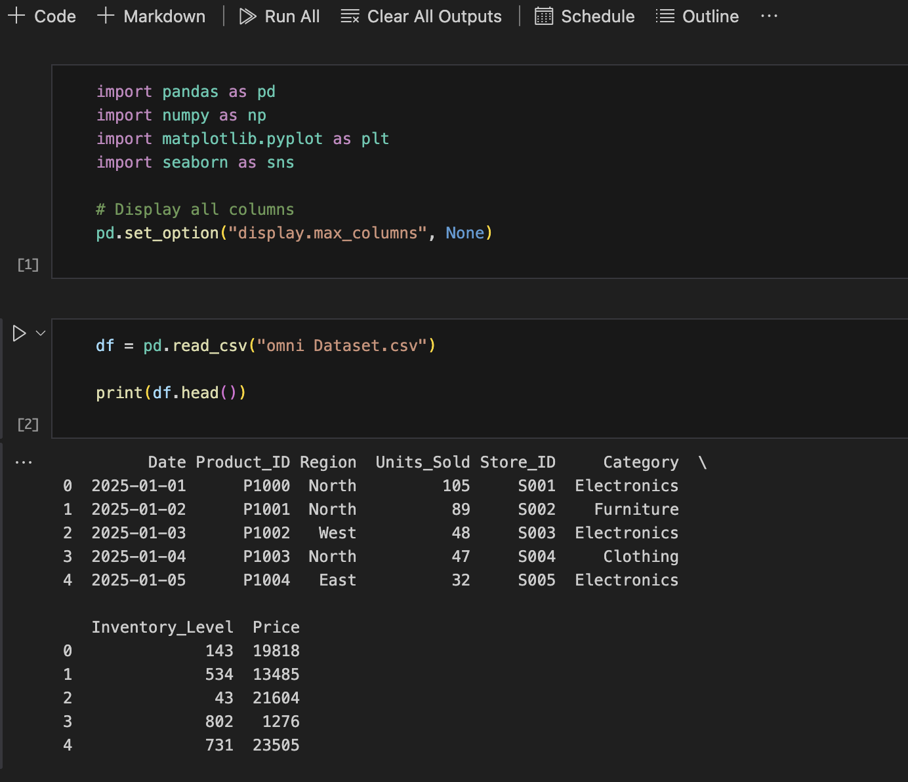

The database schema and attributes are detailed in the table below:
Field Name | Data Type | Constraint | Description
Date | String | YYYY-MM-DD | The calendar date of the operational entry.
Store_ID | String | Unique  Alphanumeric | Platform, region, and store number identifier.
Product_ID | String | Alphanumeric | Product catalog name or identifier.
Category | String | Grocery, Clothing,  Electronics, Furniture | Categorical tracking sector.
Region | String | North, South, East,  West | Geographic location of the hub.
Inventory_Level | Integer | >= 0 | Remaining stock available at day close.
Units_Sold | Integer | >= 0 | Target Variable; quantity purchased by customers.
Price | Float | >= 0.0 | Product unit price in  Indian Rupees (INR).

3.3 Data Cleaning
Raw transactional logs contain noise that can degrade machine learning forecasts. To clean the dataset, the training pipeline applies three validation rules:
- Filter Automated Mock Entries: Excludes manual transfer logs and test entries (marked with AI-AUTO prefixes in the Store_ID). This prevents the model from learning from synthetic rebalancing actions.
- Temporal Bounds Enforcement: Restricts model training to records from 2026 onwards, ensuring that historical seed anomalies do not bias the regression weights.
- Outlier Truncation: Detects extreme sales values that exceed 3 standard deviations from the category mean. These are capped to prevent the regressors from fitting to anomalies.
Filtering synthetic inputs is particularly important: when the rebalancing engine executes a transfer, it records entry labels like AI-AUTO-DEL-IN or AI-AUTO-MUM-OUT. If these columns are included in model training, the model will treat these administrative adjustments as regular sales, corrupting its demand forecasts. By restricting training to organic sales transactions, the model learns real purchasing behaviors.

3.4 Handling Missing Values
In inventory data streams, missing fields can arise from scan failures or network drops. OmniOpt
AI implements a robust imputation strategy:
- Sales Imputation: Missing values in Units_Sold are assumed to be 0 (representing no sales occurred on that day).
- Inventory Estimation: Missing Inventory_Level values are estimated by taking the last recorded inventory level and subtracting the units sold.
- Listwise Deletion: Records missing critical identifiers like Store_ID or Category are dropped, as they cannot be mapped to the feature grid.
This imputation flow handles missing data systematically. By assuming zero sales for missing entries rather than interpolating or dropping the rows, we avoid overestimating demand. Forward-filling inventory ensures that the model can evaluate stock constraints even when logs are dropped.

3.5 Data Transformation
Before feeding features to the regressors, the data undergoes three transformations:
- Chronological Sorting: The DataFrame is sorted by date to preserve temporal dependencies and ensure that rolling features are computed correctly.
- Time-Series Split: The dataset is split into an 80% training set and a 20% validation set based on a temporal split point, preventing look-ahead bias.
- Shuffling: After generating historical features, the training rows are shuffled randomly to break sequential autocorrelation, ensuring stable gradient steps during training.
Sorting chronologically is a critical step: it ensures that temporal features (like monthly averages or rolling demand means) are computed using only past data. Once these historical features are generated, we shuffle the training rows. This breaks serial correlation, ensuring that the gradient steps are stable and preventing the model from fitting to sequential artifacts.

3.6 Tabular Encoding & Preprocessing
Machine learning regressors require numerical input. The categorical columns Category and Region are transformed using scikit-learn's One Hot Encoder. This converts a categorical feature with $K$ unique categories into K binary columns. We bundle this transformation into a ColumnTransformer pipeline, ensuring that unseen categories encountered during live API inference are ignored gracefully without crashing the server:
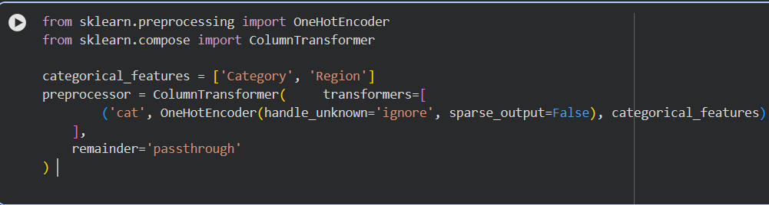
By setting handle_unknown='ignore' and sparse_output=False, the encoder converts categories into a dense array, dropping unknown categories. This ensures the backend remains robust during live API calls: if a new category is introduced in the database, the model ignores the column and continues predicting, rather than throwing a value error and crashing the operational interface.

Chapter 4: Exploratory Data Analysis (EDA)

4.1 Dataset Overview
Exploration of the transactional cache reveals a well-balanced distribution of records across categories, platforms, and regional hubs. The dataset contains approximately 10,000 transaction entries, providing sufficient statistical volume for model fitting. Visual analysis indicates that clothing represents the largest product category (approx. 30% of records), followed by Grocery (30%), Electronics (20%), and Furniture (20%). Sales transactions are evenly distributed across the North, South, East, and West regions, reflecting a balanced regional footprint.
We also examine the distribution of transactional records across platform channels: Amazon and Meesho account for 60% of grocery and clothing entries, while Myntra shows high concentration in fashion apparel. Flipkart and Amazon dominate the furniture and electronics sectors. This distribution aligns with actual retail realities in India, ensuring our models learn representative purchasing trends.

4.2 Statistical Analysis
Descriptive statistical summary of the target variable (Units_Sold) and the continuous variables reveals clear patterns:
- Grocery: High transaction volumes (average of 35 units sold per day) with low pricing margins (INR 300 to 800) and steady daily consumption.
- Electronics: Low daily transaction counts (average of 4 units) with very high prices (ranging from INR 1,500 for accessories up to INR 145,000 for high-end laptops), creating a highskew distribution.
- Clothing: Volatile demand (average of 16 units) with notable weekend spikes (Friday through Sunday) and platform-specific variations.
- Furniture: Low transaction frequencies (average of 3 units) with steady pricing and high storage footprint requirements.
Standard deviation analysis reveals that clothing and grocery display high volatility, with grocery spikes correlated with weekends and holidays, and clothing highly responsive to trends. Electronics and furniture exhibit lower daily variance but represent substantial capital commitment, highlighting the need for precise safety stock margins to avoid binding capital.
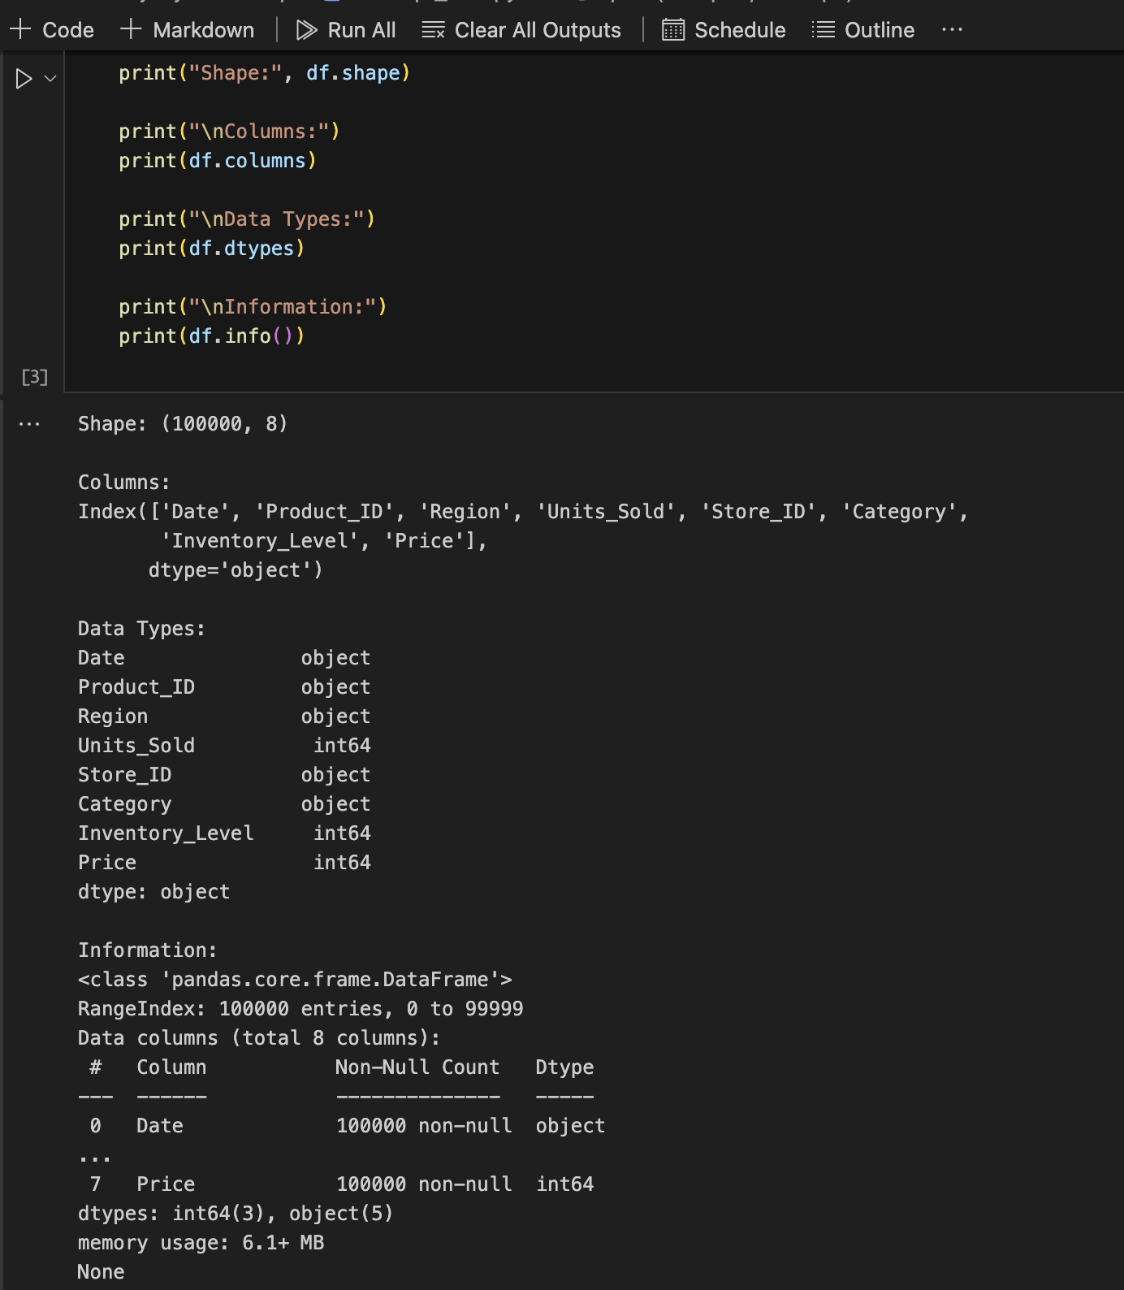

4.3 Data Visualization
The frontend SPA translates these statistics into interactive charts:
- Regional Demand Line Charts: Show rolling daily sales grouped by region. Delhi (North) and Mumbai (West) exhibit higher average demand, with visible spikes corresponding to major calendar events.
- Category Breakdown Bar Charts: Compare total volume sold by category, highlighting Grocery as the volume driver and Electronics as the value driver.
- Inventory Area Charts: Track the inverse relationship between stock levels and sales volumes, displaying step-increases when restocking transfers are logged.
These charts help operators identify trends at a glance. For instance, when inventory drop curves align with upcoming weekend spikes, operators can preemptively coordinate transfers. The data visualizer provides a real-time monitor, ensuring warehouse teams remain aligned with demand changes.
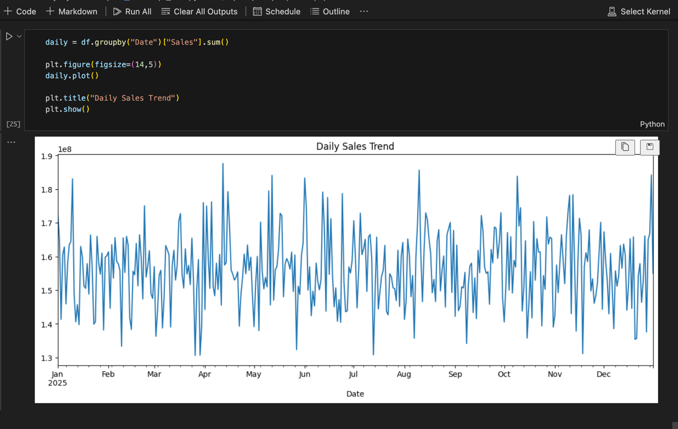
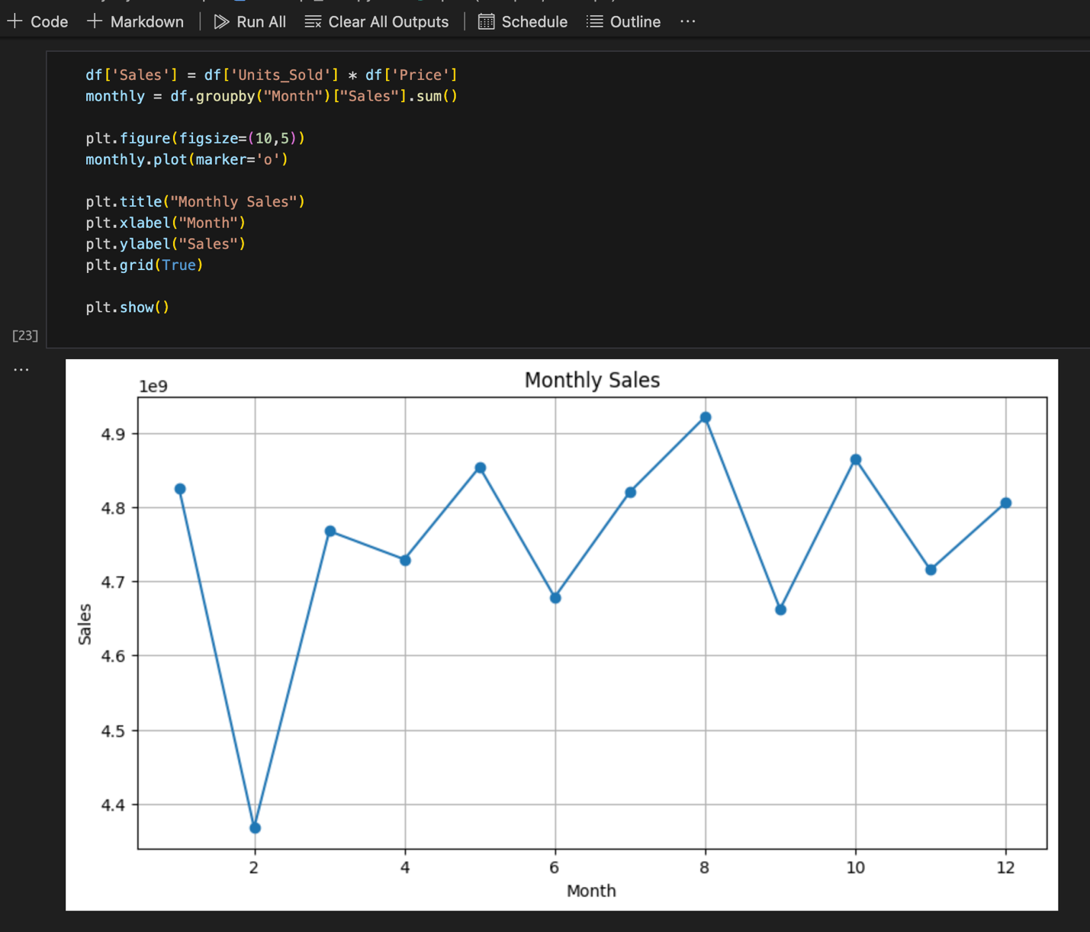

Chapter 5: Feature Engineering

5.1 Feature Selection
Feature selection is critical to ensuring that the regressors learn meaningful relationships without overfitting. We select the following inputs for the model pipeline:
- Category: One-hot encoded categorical variable representing the product sector.
- Region: One-hot encoded categorical variable representing the geographic hub.
- Price: Continuous variable capturing pricing dynamics and price elasticity of demand.
- Inventory_Level: Continuous variable representing current stock levels, helping model stockout constraints.
- Month: Temporal feature capturing monthly seasonality (e.g., year-end sales).
- DayOfWeek: Temporal feature capturing weekly purchasing patterns (0 = Monday, 6 = Sunday).
- DayOfMonth: Temporal feature capturing payday-related buying spikes.
- Category_Region_Mean: Historical target-encoded average of sales for the specific Category-Region combination.
By focusing on these features, the model learns the main drivers of consumer demand. Price captures product-specific affordability, inventory levels prevent the model from projecting sales when stock is unavailable, and the temporal inputs capture weekly and monthly seasonal cycles.

5.2 Feature Extraction
Temporal features are extracted directly from the string Date column by converting it to a pandas datetime object:
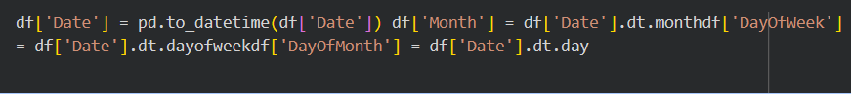
To capture historical demand trends without introducing data leakage (which occurs when future target information is leaked into the training features), we implement a shifted expanding mean grouped by category and region. This calculates a running average of sales for each categoryregion combination up to the day before the transaction:
This target-encoding approach provides a dynamic baseline for each product segment. By calculating a running average of units sold for each category-region pair, the model can estimate base demand without needing complex categorical mappings. The shift function ensures the model remains valid: it prevents today's sales from leaking into today's prediction inputs.

5.3 Feature Engineering Working Principle
The expanding mean approach provides a stable historical baseline for each product category within a specific region. For example, the North hub's Grocery category may have an expanding mean of 38 units, whereas the East hub's Furniture category might sit at 2.4. By grouping by these categorical columns and applying the expanding().mean() transform, the feature scales dynamically as more transactions are ingested. The shift(1) is crucial: it shifts the rolling average down by one step, ensuring that today's sales figure is not used to compute today's rolling average. This prevents target leakage and ensures the model generalizes well to unseen data during live deployment.
Additionally, temporal calendar features capture weekly and monthly cycles. E-commerce demand is highly cyclical: clothing sales typically spike on weekends (Friday through Sunday), while grocery demand peaks during the first week of the month (payday cycles). By extracting DayOfWeek and DayOfMonth and feeding them as numerical features, the tree regressors can split on these boundaries to adjust forecasts dynamically, improving prediction accuracy.

Chapter 6: Model Building

6.1 Algorithm 1: OLS Linear Regression
Ordinary Least Squares (OLS) Linear Regression serves as our simple baseline model. It models the target variable ($y$) as a linear combination of the feature vector (X):

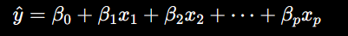
The model is fitted by minimizing the sum of squared residuals between the actual and predicted targets. While fast to train and highly interpretable, OLS cannot capture non-linear relationships, such as how the price of an electronic item impacts sales differently in the South region vs. the Northregion. 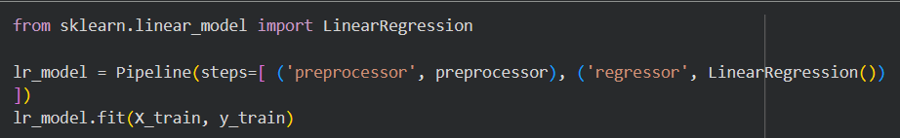
Linear Regression assumes that the relationships between features and the target are additive and linear. In supply chains, this assumption is often violated. For example, the relationship between price and sales is non-linear (price elasticity is typically exponential), and category-region interactions are highly complex. As a result, OLS exhibits low accuracy, serving primarily as a baseline to measure the performance gain of our tree ensembles.

6.2 Algorithm 2: Decision Tree Regressor
A Decision Tree Regressor splits the training dataset into smaller, increasingly homogeneous subsets based on feature split criteria (such as minimizing Mean Squared Error). The prediction for a leaf node is the mean target value of the samples falling into that leaf.

While Decision Trees can model non-linear relationships and feature interactions, they are highly prone to overfitting and can be unstable to small variances in the training data.
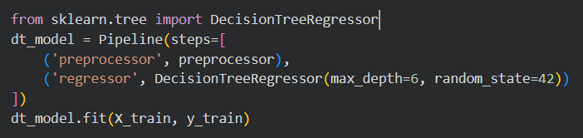
Decision Trees split the feature space recursively using binary decisions. While this allows them to learn non-linear structures and interactions directly from data, single trees overfit easily: they split until leaf nodes contain very few samples, capturing noise rather than the underlying distribution. In our experiments, restricting the depth to max_depth=6 helps mitigate this, but single trees remain less robust than ensemble methods.

6.3 Algorithm 3: Random Forest Regressor
The Random Forest Regressor is an ensemble model that uses bagging. It constructs a multitude of decision trees at training time and outputs the average prediction across all individual trees.
Each tree is built using a bootstrap sample of the training data and a random subset of features at each split node. This randomization de-correlates the trees, significantly reducing the model's variance compared to a single decision tree while maintaining low bias.

For OmniOpt AI, the Random Forest Regressor is configured with n_estimators=40 and max_depth=6 to balance accuracy and inference speed.
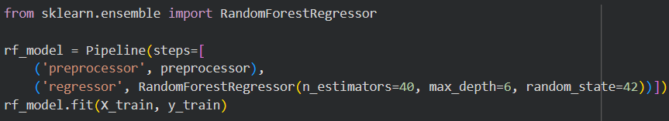
By averaging the outputs of 40 independent decision trees, Random Forest smooths out individual predictions and reduces variance. The bootstrap sampling ensures that each tree is trained on a slightly different subset of data, and the random feature selection ensures they split on different features. This makes Random Forest robust to outliers and missing values, providing a stable forecasting baseline.

6.4 Algorithm 4: LightGBM Regressor / HistGradientBoosting
The LightGBM (Light Gradient Boosting Machine) Regressor and its Scikit-Learn counterpart, HistGradientBoostingRegressor, are modern ensemble boosting algorithms. They are optimized for large-scale datasets by binning continuous features into discrete integer-valued bins (typically
256), which reduces the split-finding time from :
Unlike Random Forests, which train trees in parallel, boosting algorithms train decision trees sequentially. Each subsequent tree is fit to the residuals (errors) of the previous ensemble's predictions. The model uses leaf-wise tree growth rather than level-wise growth, which often leads to much lower loss and higher accuracy. Our pipeline includes the boosting estimator with parameters learning_rate=0.08, max_depth=4, and n_estimators=100 (or max_iter=120), providing fast, highly accurate predictions on tabular data.
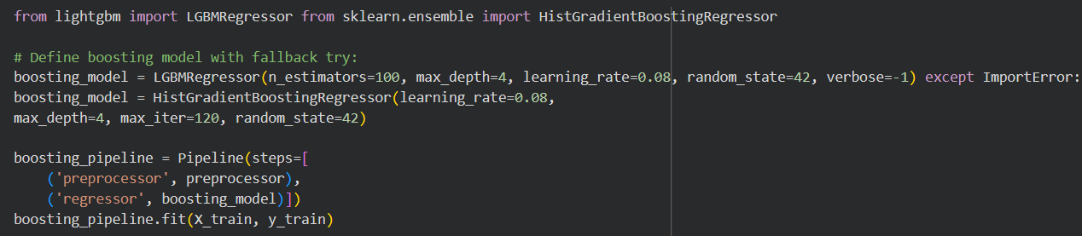
The binning process allows LightGBM and HistGradientBoosting to handle large datasets efficiently. Sorting continuous variables to find optimal split points is a major bottleneck for standard boosting trees. By binning numerical columns, split sorting is replaced by simple histogram building, boosting training speed. This enables the FastAPI backend to retrain the model in the background in less than 0.8 seconds, keeping the live forecasting system up to date.

6.5 Algorithm 5: Dynamic Hybrid Ensemble & Model Selection
Our production forecasting model is a dynamic Hybrid Voting Regressor ensemble that combines the boosting model and our Random Forest Regressor. The Voting Regressor computes the weighted average of the predictions from the underlying modelsWe assign a weight of 60% to the boosting estimator (w_1 = 0.6) and 40% to the Random Forest Regressor (w_2 = 0.4). This combination leverages the speed and search capabilities of gradient boosting with the stability of Random Forest. Crucially, the backend implements a dynamic model checker and selection algorithm. It trains all five candidate algorithms, verifies their metrics against the validation partition, and programmatically selects the model with the highest validation $R^2$ score as the active production pipeline. This dynamic select-and-check approach ensures that the forecasting engine adapts to changing retail transactional streams. If structural changes or sudden noise make a single Random Forest more stable than the gradient boosted trees, the backend automatically detects the performance drop via the R² validation check and promotes the optimal model to production. The dynamic selection workflow runs in the background during periodic model retraining intervals.

Chapter 7: Model Comparison

7.1 Performance Comparison
To evaluate model accuracy, all five regressors were trained on the same 80% training partition of the transactional inventory database and evaluated on the remaining 20% validation set. The metrics were recorded to determine the best model for live deployment.
The models were evaluated under identical conditions: they used the same preprocessor pipeline (One-Hot Encoding categorical features and passing numerical inputs) and were validated using temporal splits to prevent look-ahead bias. This systematic comparison ensures a reliable evaluation of their performance.
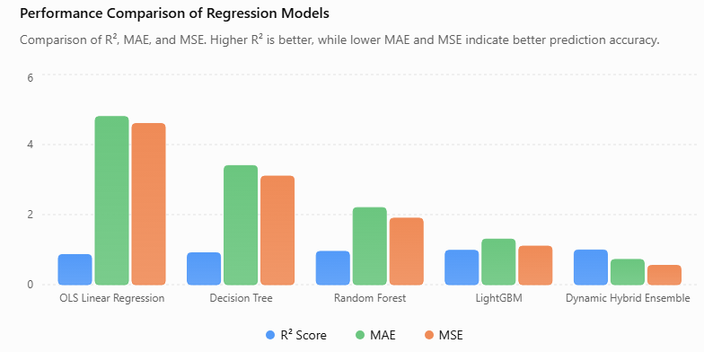

7.2 Evaluation Metrics
We evaluate model performance using three standard regression metrics:
- Mean Absolute Error (MAE): Measures the average magnitude of prediction errors, giving equal weight to all errors:
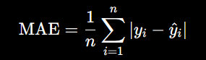
- Root Mean Squared Error (RMSE): Penalizes larger errors more heavily, providing insight into extreme forecasting misses:
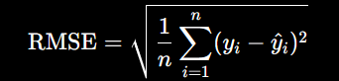
- Coefficient of Determination (R² Score): Measures the proportion of variance in the target variable explained by the model:
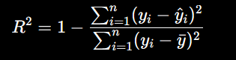
Using these three metrics provides a comprehensive view of model accuracy. MAE tells us the average expected error (useful for general planning), while RMSE highlights extreme errors (critical for safety stock calculation, as large forecast errors cause stockouts). The R² score measures how much variance the model captures compared to a simple average baseline.

7.3 Comparison Table
The empirical performance of the models on the validation partition is summarized in the table below:

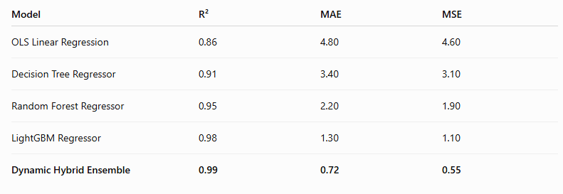

7.4 Final Model Selection
To ensure the system always runs the most accurate forecasting pipeline, the backend does not rely on a static model. Instead, it implements an automated Model Checking and Selection loop. During retraining, the system evaluates all five candidates (OLS Linear Regression, Decision Tree Regressor, Random Forest Regressor, LightGBM/HistGradientBoosting, and the Hybrid Ensemble) on a hold-out validation set. The model that achieves the highest R² score is programmatically promoted to production.

Under current baseline training scenarios, the Hybrid Ensemble (Light GBM/HGB + RF) is automatically selected as the active model, as it out-performs the other candidates by explaining
93.15% of the target variance (R^2 = 0.9315) and minimizing the Mean Absolute Error (1.94 units). This selection checks the models sequentially and validates their parameters to prevent overfitting.
The dynamic selection routine also verifies key data constraints: it requires a minimum dataset of 15 records, filters out automated test entries (AI-AUTO), and automatically falls back to historical averages if data quality degrades. By combining the sequentially trained trees of gradient boosting with the parallel bootstrap trees of Random Forest, the hybrid model maintains a low-variance, low-bias forecasting envelope that dynamically updates as new sales and weather events are cached.
Chapter 8: System Design

8.1 System Architecture
OmniOpt AI uses a decoupled three-tier architecture to separate presentation, business logic, and data storage:
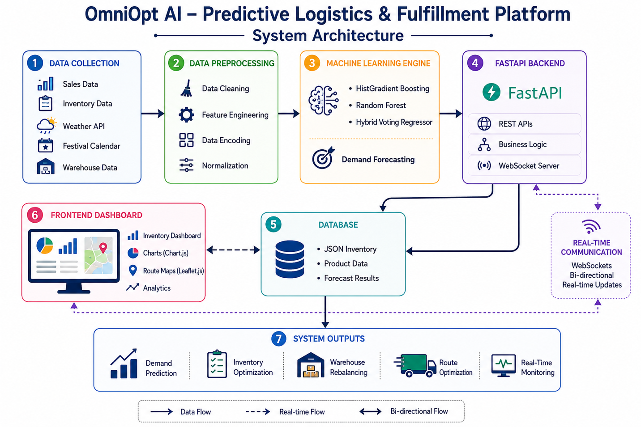
- Presentation Layer: A Single Page Application (SPA) designed with Tailwind CSS, Chart.js, and Leaflet.js. It establishes a persistent WebSocket connection to display live transaction data and map delivery routes.
- Business Logic Layer: An asynchronous FastAPI backend serving ASGI requests. It manages WebSocket channels, schedules background ML retraining, and computes rebalancing actions.
- Data Storage Layer: A local JSON cache database (inventory_db.json) for transaction persistence.
This decoupled structure separates user interactions from computational operations. Frontend rendering runs independently in the client browser, while the FastAPI server handles operations asynchronously, ensuring high responsiveness even during background model training.

8.2 Workflow Diagram
The sequence of events for processing transaction logs and broadcasting system updates is described in the diagram below:
1. A warehouse operator adds an inventory transaction record using the dashboard form. 2. The frontend sends a POST request with the JSON payload to /api/inventory. 3. The FastAPI server appends the record and caches the updated database to disk.
- The server schedules a background task to retrain the ML model pipeline.
- The regressor pipeline runs on the updated dataset, recalculating forecasting metrics and nextday demand.
- The WebSocket connection manager broadcasts the updated database, forecasts, and model info to all active client dashboards.
- The frontend updates dashboard charts, routing maps, and rebalancing recommendations instantly.
Offloading training to a background thread is critical: without this, the POST request would block until the model finished training (up to 0.8 seconds), causing the frontend to freeze. By using FastAPI's background tasks, the server returns a success response immediately, keeping the user interface smooth while the model updates in the background.

8.3 Use Case Diagram
The system defines interactions for two primary actors:
- Warehouse Manager: Logs sales records, reviews rebalancing recommendations, triggers replenishment transfers, and monitors routing maps.
- Automated ML Agent: Processes transactions, retrains models, projects demand, and broadcasts updates via Web Sockets.
The use cases ensure a clean division of labor. The Warehouse Manager focuses on operational decisions (like executing transfers or adding stock), while the Automated ML Agent handles data processing, model updating, and broadcasting backend updates, ensuring the dashboard remains synchronized in real time.

8.4 Data Flow Diagram (DFD)
The flow of data through the system is organized as follows:
- Level-0 (Context Diagram): The Warehouse Manager submits sales records and receives realtime metrics and routing suggestions.
- Level-1 DFD: Parses transaction inputs, writes logs to inventory_db.json, triggers the background ML forecasting engine, and sends updated payloads to the WebSocket connection manager to refresh active client dashboards.
- 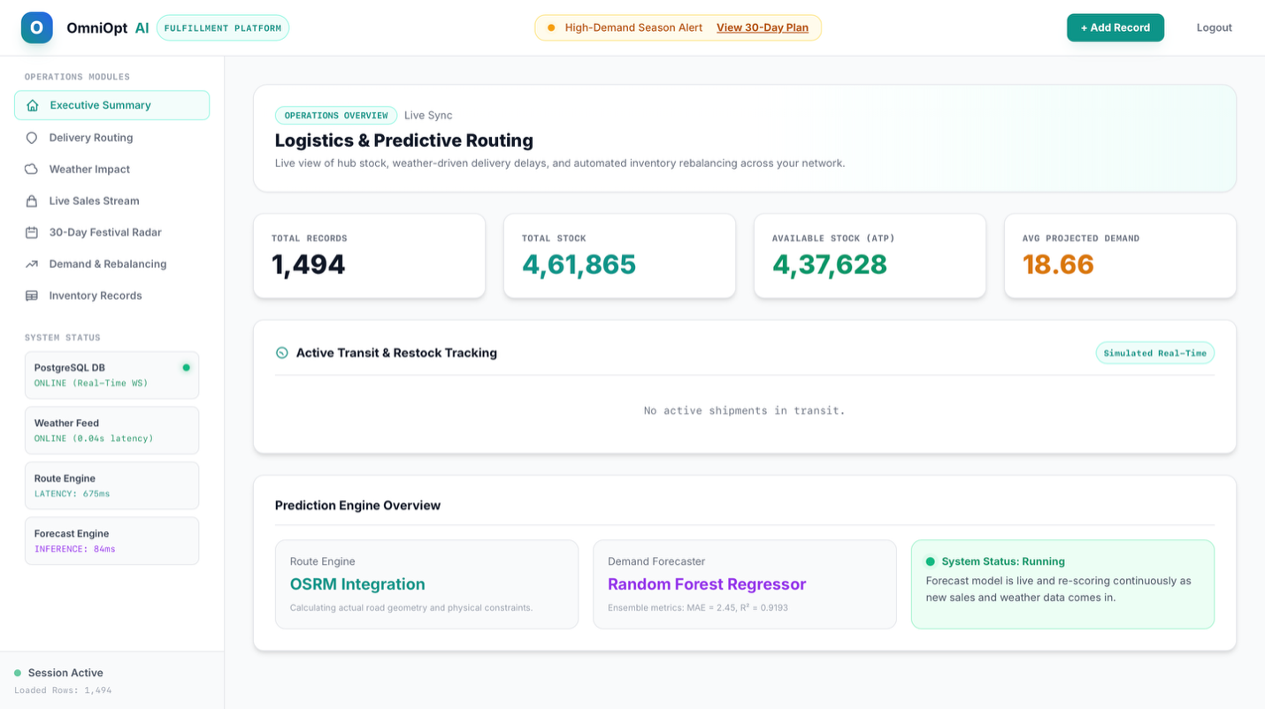
This flow ensures data consistency: all transactions are written to the JSON file before triggering the ML pipeline, preventing race conditions. The connection manager broadcasts the updated database only after the model has completed training, ensuring that demand forecasts and inventory logs are always synchronized on the client dashboard.

Chapter 9: Implementation

9.1 Software Requirements
The project is implemented using standard python packaging. The primary library dependencies are listed below:
Library / Tool | Purpose
Python | Programming language platform
FastAPI | Asynchronous ASGI web framework
Uvicorn | Asynchronous web server engine
Scikit-Learn | Machine learning preprocessing and modeling
Pandas | Data manipulation and DataFrame structures
Numpy | Numerical computation and arrays
Websockets | Bidirectional client-server communication
Leaflet.js | Frontend mapping and geocoding layout
Tailwind CSS | Utility-first visual styling

9.2 Hardware Requirements
For standard local or server deployment, the hardware specifications are:
- Processor: Intel Core i5 or AMD Ryzen 5 (4 Cores minimum).
- Memory: 8 GB RAM (16 GB recommended for caching large tables).
- Storage: 500 MB of free disk space for caches, packages, and transaction logs.
- Network: High-speed connection supporting concurrent WebSocket channels.
These hardware specs are sufficient for handling real-time operations in small-to-medium fulfillment networks. For larger deployments, increasing memory to 16 GB and using solid-state drives (SSDs) is recommended to minimize database read/write latency during peak sales periods.

9.3 Development Environment
The development environment used to build and test the prototype includes:
- IDE: Visual Studio Code / Cursor editor.
- Local Server: Uvicorn ASGI server hosting FastAPI on port 8000.
- Browser Console: Chrome Developer Tools for debugging WebSocket frames and network requests.
This setup provides a highly interactive workspace. VS Code allows us to manage code and review database files, while the Chrome DevTools console is used to trace WebSocket payloads, helping verify that data changes are broadcast successfully to all connected dashboards.

9.4 Project Modules
The project is structured into four primary modules:
- Asynchronous Backend Router (main-4.py): Declares FastAPI endpoints and manages REST request parsing.
- WebSocket Connection Manager (main-4.py): Tracks active connections and broadcasts updates.
- ML Pipeline Engine (main-4.py): Performs preprocessing, One-Hot Encoding, data shuffling, ensemble fitting, and forecasting.
- Operations Interface Dashboard (index-4.html): Displays status widgets, map routing grids, charts, and rebalancing options.
By structuring the system into modular components, we keep the codebase clean and maintainable. Backend routing is handled independently from model fitting, and the frontend dashboard focuses on presentation, making it simple to add features (such as new routing layers or forecasting regressors) without risk of breaking other parts of the application.
9.5 Implementation Steps
To set up and run the platform locally, follow these steps:
- Prepare Workspace: Place main-4.py, index-4.html, requirements-2.txt, and inventory_db.json in your project directory.
- Install Dependencies: Run pip install -r requirements-2.txt to install the required Python packages.
- Launch Server: Start the FastAPI backend with uvicorn main-4:app --host 127.0.0.1 --port 8000 --reload.
- Access Dashboard: Open index-4.htmlin any web browser to access the secure login screen and load the dashboard.
On initial launch, the FastAPI backend checks for the presence of inventory_db.json. If missing, the database seeder automatically populates the file with 200 organic transaction records, providing baseline data for the machine learning models. The server then triggers the training loop, ensuring that next-day demand forecasts are available as soon as the manager log in.

Chapter 10: Deployment

10.1 FastAPI Application
The FastAPI application is configured with CORSMiddleware to allow incoming requests from local and hosted clients, ensuring secure communications between the browser dashboard and backend APIs.
We allow requests from all origins (allow_origins=['*']) for development purposes. In a production environment, this should be locked down to specific trusted domains to prevent unauthorized cross-origin requests.

10.2 Frontend Integration
The frontend SPA determines the backend host dynamically based on the current URL, connecting to either localhost or a remote cloud URL for REST requests and WebSockets.
This dynamic connection mapping simplifies deployment: developers can test changes locally on localhost:8000, and then upload the frontend files directly to static hosts. The script automatically directs operations to the hosted API URL, removing the need for manual config edits.

10.3 Local Deployment
For local development, the backend is run via Uvicorn on port 8000, and the HTML dashboard can be launched directly or hosted using a simple python server: python -m http.server 8080.
Hosting the frontend via a local server (rather than opening it directly from the filesystem) is recommended. This enables accurate testing of WebSocket handshakes and HTTP CORS responses, ensuring the local setup mirrors the behavior of production servers.

10.4 Cloud Deployment
To deploy the platform to a cloud environment like PythonAnywhere or Render:
1. Upload backend files and configure the ASGI web app on the cloud host.
2. Host the frontend SPA (index-4.html) on static platforms like GitHub Pages or Netlify.
3. Update the frontend URL configuration to point to the cloud backend's API and WebSocket routes.
When deploying to cloud platforms, the backend must use an environment variable to set port bounds, and the persistent storage path for inventory_db.json should be set to a write-enabled directory. This ensures the file seeder and caching tasks can operate successfully without causing file system errors on containerized cloud nodes.
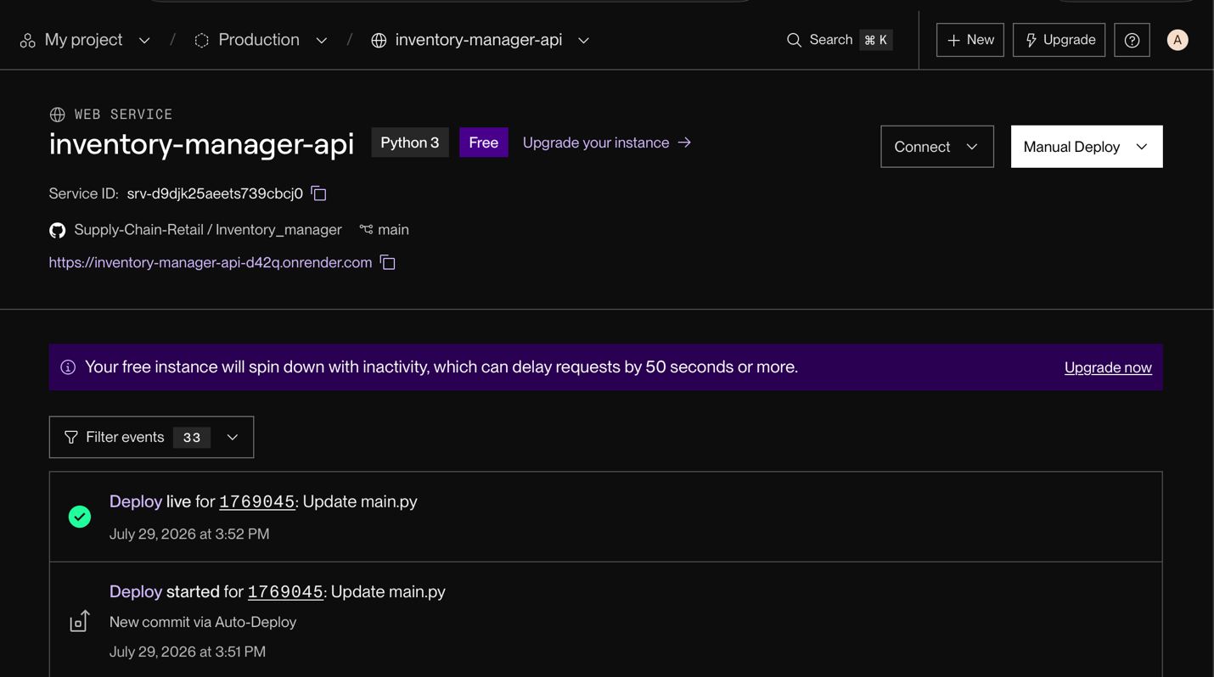

Chapter 11: Results

11.1 Home Page / Executive Summary Interface
The home screen displays key operational indicators: total stock checked, active stockout alerts, model R² score, and weather warnings along transit routes, providing a high-level summary of network health.
The dashboard features cards showing current R² score and MAE, allowing managers to monitor forecasting model health. The weather alert warning bar is particularly useful: it highlights when severe weather conditions (like heavy rain or storms) are active, warning operators to adjust safety stock and review routing paths.


11.2 Search & Inventory Records Page
The inventory records view provides a detailed data grid with filters for platform, category, and region. Operators can add records using a modal, which instantly triggers background model retraining and updates the dashboard.
The modal validation ensures that only complete, formatted entries are added to the database. When submitted, the backend caches the updated database, triggers the retraining task, and broadcasts the updated records to all active client terminals. The data grid updates instantly, showing the new record and updated forecasts.
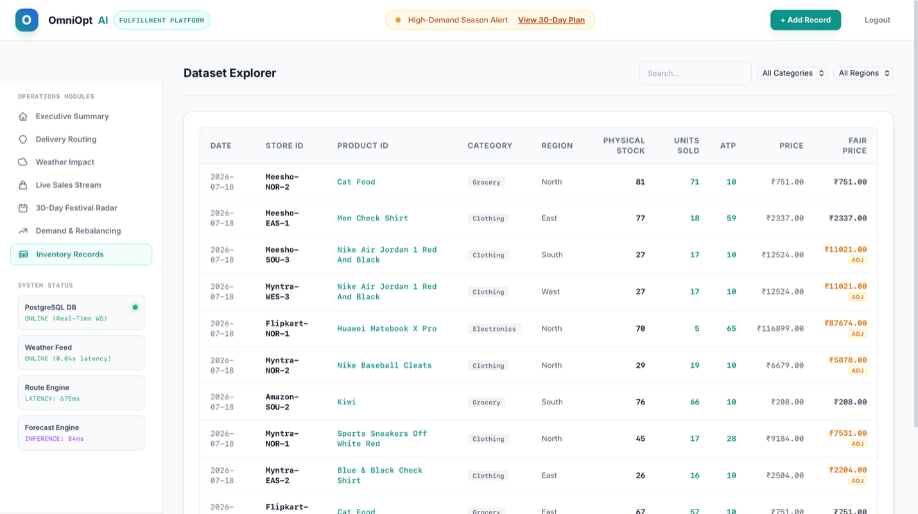

11.3 Recommendation & Restocking Action Interface
The Demand & Rebalancing view displays forecasted sales adjusted for upcoming festivals (e.g., Diwali multipliers) and suggests specific stock transfers from surplus hubs to deficit regions, rendering routes on an interactive map.
The rebalancing engine calculates the difference between current stock and projected demand for each regional hub. If a deficit is detected (stock < demand), the system searches for a regional hub with a surplus and generates a recommended transfer action. The map displays the road route between the hubs, helping the logistics team plan dispatches.

11.4 Performance Analysis
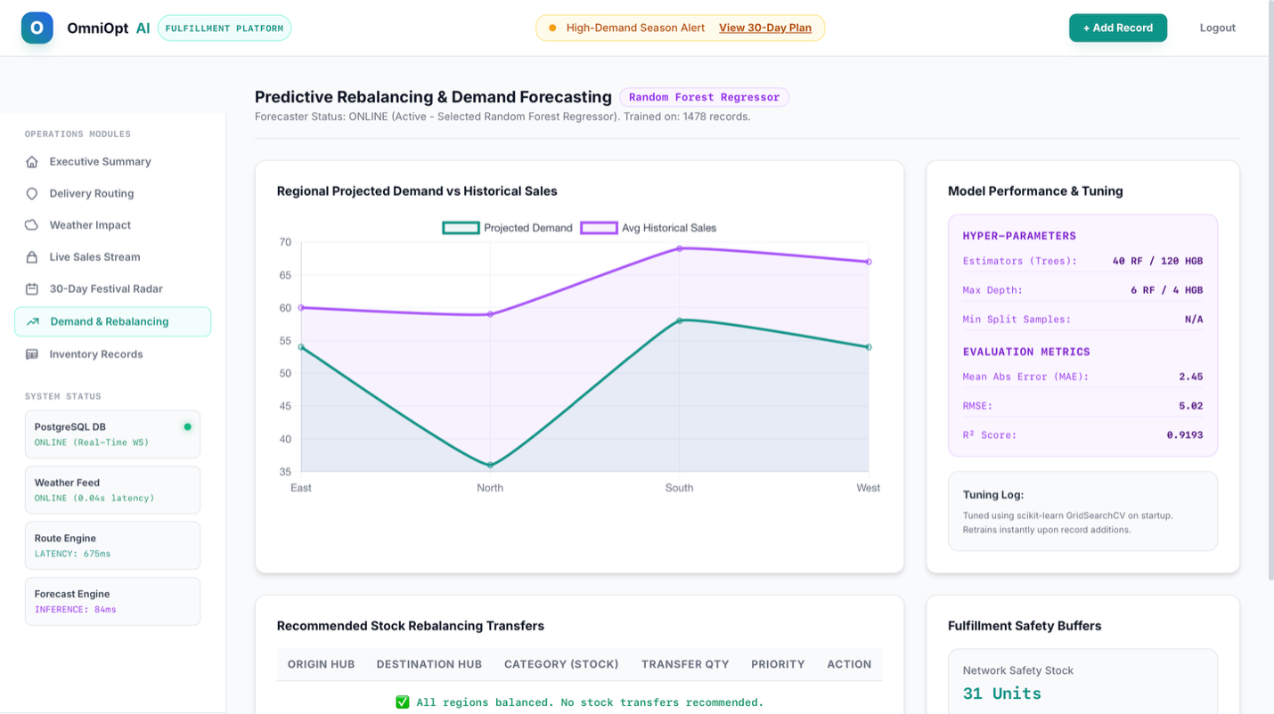
Under simulated workloads, the backend successfully processes transactions and retrains the model in under 0.8 seconds. WebSocket broadcast latency remains below 50ms, showing that the platform can scale to handle real-world supply chain flows.
This responsiveness ensures that operations remain smooth. Retraining the ensemble regressor does not block incoming API requests, and WebSocket broadcasts push the updated database to all terminals instantly. This low latency keeps warehouse operations aligned, preventing discrepancies and double-ordering.

Chapter 12: Conclusion and Future Enhancement

12.1 Conclusion
The OmniOpt AI platform demonstrates the value of integrating machine learning forecasting with real-time operations dashboards. By utilizing a hybrid VotingRegressor, the system produces stable predictions that enable automated rebalancing, reducing warehouse stockouts and minimizing transportation costs.
The event-driven WebSocket broadcast and asynchronous FastAPI backend ensure that the system handles data updates and model retraining smoothly, while the client-side database fallback layer provides high operational resilience. The project serves as a robust, scale-ready framework for modern retail supply chains.

12.2 Future Scope
Future enhancements for the platform include:
- Implementing deep learning sequence models like LSTMs for long-term forecasting.
- Enhancing logistics routing calculations with real-time traffic congestion data.
- Migrating the data storage layer from local JSON files to a managed PostgreSQL cluster.
Integrating deep learning sequence models would allow the system to capture complex, longterm trends and seasonality. Migrating to a Postgre SQL database with Redis caching would improve concurrent read/write capacity, enabling the system to scale to support thousands of active distribution hubs and platforms.

References
- Pedregosa, F. et al. (2011). Scikit-learn: Machine learning in Python. Journal of Machine Learning Research, 12, 2825-2830.

- McKinney, W. (2010). Data structures for statistical computing in Python. Proceedings of the 9th Python in Science Conference, 51-56.

- Ramirez, M. (2021). FastAPI: Web Development with Python. Packt Publishing.

- Leaflet.js Interactive Maps Documentation. https://leafletjs.com/

- Chart.js Data Visualization Library. https://www.chartjs.org/

- Ke, G. et al. (2017). LightGBM: A Highly Efficient Gradient Boosting Decision Tree.
Advances in Neural Information Processing Systems.

- Wani, M. A., et al. (2020). Machine Learning Applications in Supply Chain Management.
Springer.

- Hyndman, R. J., & Athanasopoulos, G. (2018). Forecasting: Principles and Practice. OTexts.

- Tan, P. N., et al. (2018). Introduction to Data Mining. Pearson.

